


Contact Information:

Name:
Address:
(City, State, Zip)
Day phone:
E-mail:
Description of Disability (if any):
Type of Assistive Technology (if any):
Location of Route:

If you are not able to answer YES to a question, check as many problems as are applicable. In addition, please note the approximate locations you encountered each problem.

Please return to: Florida Department of Transportation
ADA/Accessibility Program
605 Suwannee Street, MS-32
Tallahassee, FL 32399-0450

- Did you have enough room to walk safely?
Yes Some problems:
No sidewalk exists
Sidewalks started and stopped
Sidewalks are too narrow
Sidewalks are blocked with poles, signs or other obstacles
Sidewalks are blocked by branches or other vertical obstacles
Adequate passing space is not provided
Other:

Location of Problems:

For more information, Contact:

Randy E. (Brad) Bradley II, P.E.
State ADA Coordinator
Ph: 850-414-4295, FAX: 850-414-5261
E-mail: brad.bradley@dot.state.fl.us

- Could you easily negotiate the sidewalk grades and cross-slopes?
Yes Some problems:
Sidewalks are excessively steep
Sidewalks have severe cross-slopes
Adequate rest areas and/or level areas are not provided
Other:

Location of Problems:

- Was the surface easy to walk on?
Yes Some problems:
Sidewalks surfaces are not firm
Sidewalks are covered with leaves or other debris
Sidewalks are broken or cracked
Gratings for trees and drainage are not avoidable
Other:

Location of Problems:

- Were the curb ramps easy to use?
Yes Some problems:
Curb ramps were not provided
Curb ramps needed repair
Puddles or debris collected at the bottom of the curb ramp
Detectable warnings were not provided
Curb ramps were too steep
Curb ramps did not have landings
Extreme street slope made entering or leaving the curb ramp difficult
Obstacle such as poles or gratings blocked the curb ramps
Curb ramps were exposed to traffic
Other:

Location of Problems:

- Was it easy to cross streets?
Yes Some problems:
Difficult to differentiate between the sidewalk and the street
Road was too wide to cross on one signal phase
Traffic signals made you wait too long
Traffic signals did not give you enough time to cross
Pedestrian controls were difficult to locate
Pedestrian controls were difficult to activate
Parked cars blocked your view of traffic
Trees or plants blocked your view of traffic
Other:

Location of Problems:

Please return to: Florida Department of Transportation
ADA/Accessibility Program
605 Suwannee Street, MS-32
Tallahassee, FL 32399-0450

- Was your walk pleasant?
Yes Some problems:
Needs more grass, plants, or trees
Too much exposure to traffic
Suspicious activity
Not well lit
Dirty; lots of litter or trash
Other:

Location of Problems:

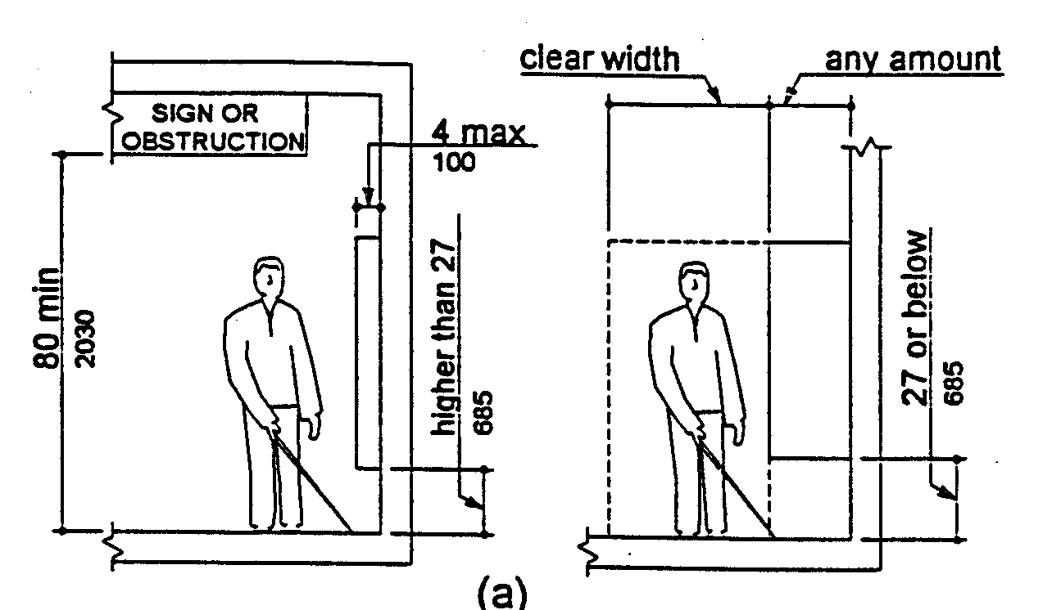

For more information, Contact:
Randy E. (Brad) Bradley II, P.E.
State ADA Coordinator
Ph: 850-414-4295, FAX: 850-414-5261
E-mail: brad.bradley@dot.state.fl.us

